YUMTASK WEB APPLICATION
GitHub Repository: https://github.com/ariadnibardani/YumTask
Introduction
YumTask is a client-side web application designed to combine productivity management with healthy lifestyle organization. Unlike conventional task management systems, YumTask focuses specifically on food-related planning, dietary organization, and structured meal coordination.
In modern life, individuals often struggle to balance professional responsibilities with maintaining proper nutrition. Busy schedules reduce time available for meal preparation, grocery planning, and healthy eating. YumTask addresses this challenge by integrating task management tools with meal-oriented planning features.
The application enables users to:
- Create and manage food-related and daily tasks
- Track productivity and completion rates
- Monitor task analytics visually
- Maintain a personalized interface via dark mode
Technologies Used
- HTML5 for structure
- CSS3 for styling and layout
- Bootstrap 5 for responsive grid system and components
- Vanilla JavaScript (ES6) for functionality
- Chart.js for analytics visualization
- LocalStorage API for persistent data storage
No backend or server-side framework is used. All data is stored in the browser.
Data Management
The application uses two main global arrays:
let tasks = JSON.parse(localStorage.getItem("tasks")) || [];
let activity = JSON.parse(localStorage.getItem("activity")) || [];
These arrays store:
- Task objects (name, description, date, priority, completion status)
- User activity history
Data persistence is achieved through:
localStorage.setItem()
localStorage.getItem()
This allows tasks and activity logs to remain available even after refreshing or reopening the browser.
I had to look up how to do these and used AI to help me out.
Centralized State Synchronization
A centralized function:
saveData()
ensures consistent synchronization between memory and LocalStorage.
After every task operation (add, edit, delete, complete), the following functions are triggered:
- renderTasks()
- updateSummary()
- renderActivity()
- renderChart()
- updateAnalyticsStats()
This guarantees UI consistency across all pages. To understand how to do the task analysis I used AI, but code was pretty much made by me.
DOM Initialization
All scripts run inside DOMContentLoaded to ensure safe DOM manipulation and avoid null element errors.
This reflects best practices in front-end development.
Task Management
Users can:
- Add new tasks
- Edit task names
- Delete tasks
- Mark tasks as completed or pending
- Filter by status
- Filter by priority
- Sort alphabetically or by date
Each task is assigned a unique ID using:
id: Date.now()
All these are found in my java script, I looked through stack overflow and AI to understand them.
Task Allocation System
The core feature of YumTask is its task allocation system.
Each task contains:
- Unique ID
- Task name
- Description
- Due date
- Priority level (Low / Medium / High)
- Completion status
Rendering Strategy
Tasks are dynamically rendered inside a table using JavaScript. After every action (add/edit/delete/complete), the table is fully re-rendered to ensure UI consistency.
Why full re-render?
- Ensures filtered and sorted views update correctly
- Simplifies state management
Filtering & Sorting
Filtering improves scalability and usability, allowing users to focus on relevant tasks.
Sorting improves clarity and management efficiency.
Both are implemented using array methods (filter(), sort()), demonstrating clean data manipulation practices.
Task Summary Dashboard
The task page includes dynamic counters:
- Total tasks
- Completed tasks
- Pending tasks
This provides dashboard-style visibility and improves user decision-making.
Latest Activity Section
The Latest Activity section logs user actions such as:
- Task creation
- Task completion
- Task deletion
- Task edits
Only the most recent 5 activities are displayed.
UX Benefits:
- Improves transparency
- Enhances workflow traceability
- Simulates enterprise task tracking systems
The activity list dynamically updates after each task action.
Analytics Dashboard
The analytics page includes:
- Pie chart visualization (Completed vs Pending)
- Completion rate percentage
- Total tasks counter
- High-priority task count
- Animated progress bar
Chart.js dynamically updates every time task data changes.
The analytics page provides visual data representation using Chart.js.
Chart Implementation
A pie chart visualizes:
- Completed tasks
- Pending tasks
Before rendering a new chart instance, the previous one is destroyed to prevent duplication errors.
Why Chart.js?
- Lightweight
- Responsive
- Easy integration
- Professional appearance
KPI Statistics
The analytics dashboard includes:
- Total tasks
- Completion rate
- High-priority tasks
- Animated progress bar
The progress bar width dynamically updates based on the completion rate, improving visual feedback.
About Us Page
The About page includes:
- Mission statement
- Feature highlights
- Technologies used
- Team section
It uses semantic HTML structure and Bootstrap grid layouts to ensure responsiveness.
The feature cards use hover animations to improve interactivity.
Contact Page Documentation
The Contact page includes:
- Bootstrap validation
- Native HTML validation
- Confirmation modal
- Embedded Google Map
Validation ensures accessibility and proper form submission control.
After successful validation, a modal dynamically displays the submitted user information, enhancing user feedback and professionalism.
Recipes & Pricing Page
This page demonstrates:
- Structured grid layouts
- Pricing plan comparison
- Feature highlighting
- Hover animations
The “Best Value” plan is visually emphasized using pseudo-elements and scaling techniques.
This page demonstrates UI hierarchy and persuasive design principles.
Latest Activity System
The system tracks the five most recent actions performed by the user.
Examples:
- Task added
- Task deleted
- Task marked completed
- Task renamed
This enhances transparency and usability.
Layout Systems Used
The CSS follows a modular, component-based structure.
- Flexbox (navigation, alignment)
- CSS Grid (hero section, dashboards)
- Responsive spacing using rem units
Dark Mode Implementation
Dark mode is implemented using a body.dark-mode class toggle.
Theme preference is saved in LocalStorage.
Benefits:
- Accessibility improvement
- Reduced eye strain
- Personalized user experience
Dark mode is implemented using:
document.body.classList.toggle("dark-mode");
Theme preference is saved in LocalStorage:
localStorage.setItem("theme", "dark");
This ensures persistent personalization.
I used the toggle mode and searched through AI too understand I, and tried to make it for each page different to make it more aesthetic.
Design System Consistency
Consistent use of:
- Border radius values
- Shadow elevation
- Hover animations
- Color palette
- Typography (Inter font)
Ensures professional UI consistency across all pages.
The design includes:
- Clear focus states
- High contrast colors
- Large clickable buttons
- Structured heading hierarchy
- Proper label associations
Contact Form Validation
The contact page includes:
- Required fields
- Email format validation
- Bootstrap validation classes
- Confirmation modal popup on successful submission
This ensures proper user input handling.
Testing & Validation
The application was tested for:
- Task creation and deletion edge cases
- Empty input prevention
- LocalStorage persistence
- Chart re-rendering without duplication
- Dark mode persistence
- Cross-page state consistency
Manual testing confirmed correct behavior across multiple browsers.
Design Philosophy
The UI was designed following principles of:
- Simplicity
- Consistency
- Readability
- Accessibility
- Minimal cognitive load
Bootstrap grid system ensures responsive design across:
- Desktop
- Tablet
- Mobile devices
Visual Hierarchy
Clear typographic structure is used:
- Primary headings (H2)
- Subheadings
- Content sections
- Button emphasis
Color coding enhances clarity:
- Green → Completed tasks
- Red → Pending tasks
- Orange → Branding accent
- Distinct pricing plan highlight
Carousel Integration
A Bootstrap carousel was implemented on the homepage to:
- Showcase testimonials
- Present application features
- Improve engagement
Image sizing and resolution were optimized to prevent blurriness.
Accessibility & Usability
The application includes:
- HTML structure
- Proper labels for forms
- ARIA labels, which I did not fully implement and understand
- High contrast color options (dark mode)
- Responsive layouts
Form validation provides user feedback using Bootstrap’s .invalid-feedback.
I wanted to add that many things I used and know where taught to me at my summer Internship and some of the basics I used in the project I took from small projects that where given to me for teaching purposes.
Lighthouse Audit Results
The website was tested using Chrome DevTools Lighthouse.
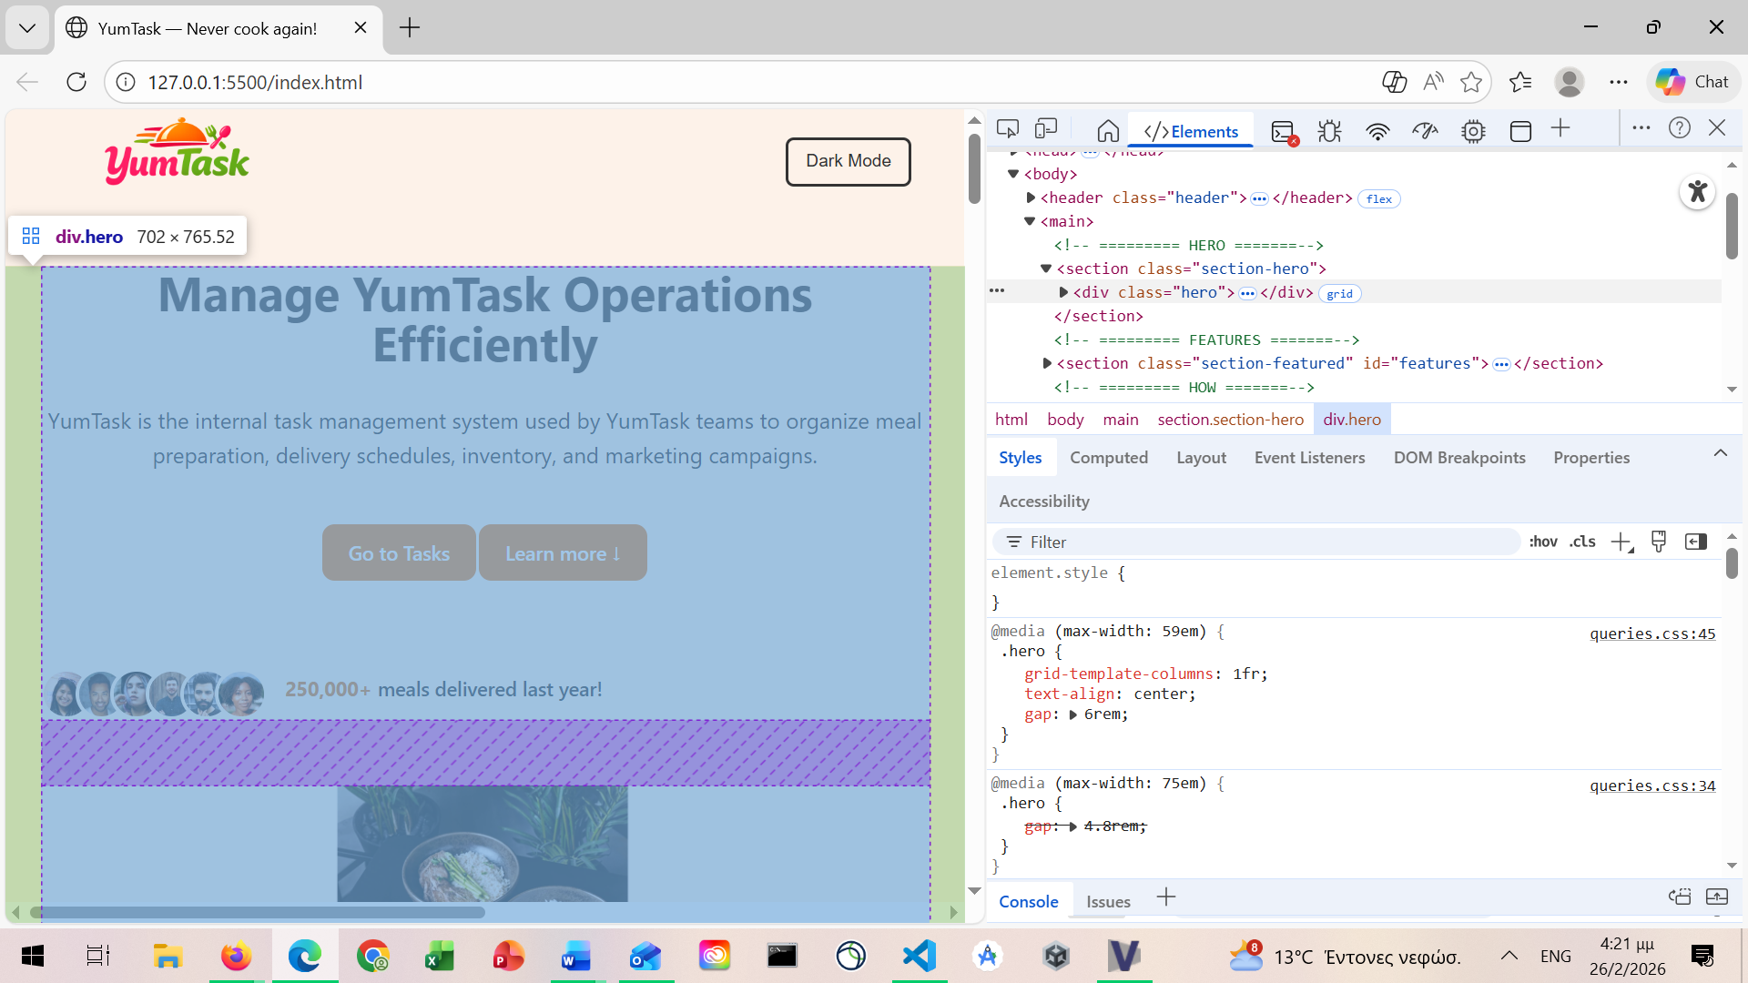
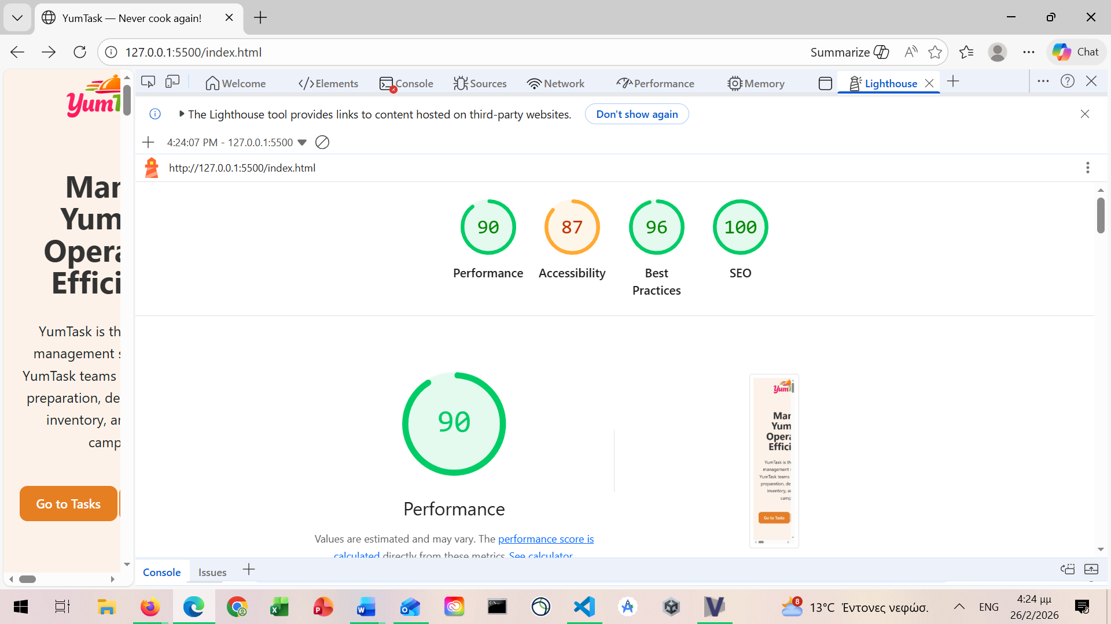Categories Tested:
- Performance
- Accessibility
- SEO
- Best Practices
Observations:
Strengths:
- Strong semantic HTML
- Mobile responsiveness
- Structured headings
- Accessible form labels
Improvements Identified:
- Image optimization
- Minor color contrast improvements
- Potential CSS/JS
Running Lighthouse helped identify technical strengths and minor weaknesses in the project. While performance and SEO are excellent, accessibility requires further refinement to ensure inclusivity. This process demonstrated the importance of testing beyond visual design and functionality, focusing also on usability, optimization, and standards compliance.Challenges Faced & Solutions
Chart Duplication Issue
Problem: Multiple charts stacking on refresh
Solution: if (chart) chart.destroy();
State Synchronization
Problem: UI not updating after modifications
Solution: Centralized update calls after every mutation
Dark Mode Styling Conflicts
Problem: Bootstrap overriding custom styles
Solution: Scoped .dark-mode overrides in CSS
Blurry Carousel Images
Problem: Low resolution scaling
Solution:
- Reduced container height
- Used object-fit
- Optimized image dimensions
Personal Reflection
This project significantly enhanced my understanding of front-end development and user-centered design.
I improved my skills in:
- State management without backend
- DOM manipulation
- Data visualization
- Responsive layout systems
- Accessibility principles
- Performance auditing
The most challenging part was ensuring synchronization between dynamic UI updates and stored data. Solving this improved my debugging and architectural thinking skills.
Additionally, using Lighthouse helped me think beyond functionality and focus on performance, SEO, and accessibility — key aspects of professional web development.
Future Improvements
Potential enhancements include:
- Backend database integration
- User authentication system
- Cloud synchronization
- Meal planning API integration
- Calendar integration
- Export to PDF
- Push notifications
- Drag-and-drop task reordering
Performance Considerations
- Lightweight client-side architecture
- No unnecessary external libraries
- Efficient DOM updates
- LocalStorage avoids server calls
- Destroying chart instance prevents memory leaks
Lighthouse testing indicated good performance and accessibility scores.
Conclusion
YumTask successfully demonstrates the development of a fully functional client-side web application integrating task management with food-oriented productivity planning.
The project showcases:
- Clean JavaScript architecture
- Proper state management
- Responsive design principles
- Data persistence using LocalStorage
- Analytics visualization with Chart.js
- Accessibility-conscious form validation
Through this project, advanced understanding was developed in:
- DOM manipulation
- State synchronization
- Front-end architecture
- User-centered interface design
- Performance optimization

